Version 17 October 2017

Overall Project Description

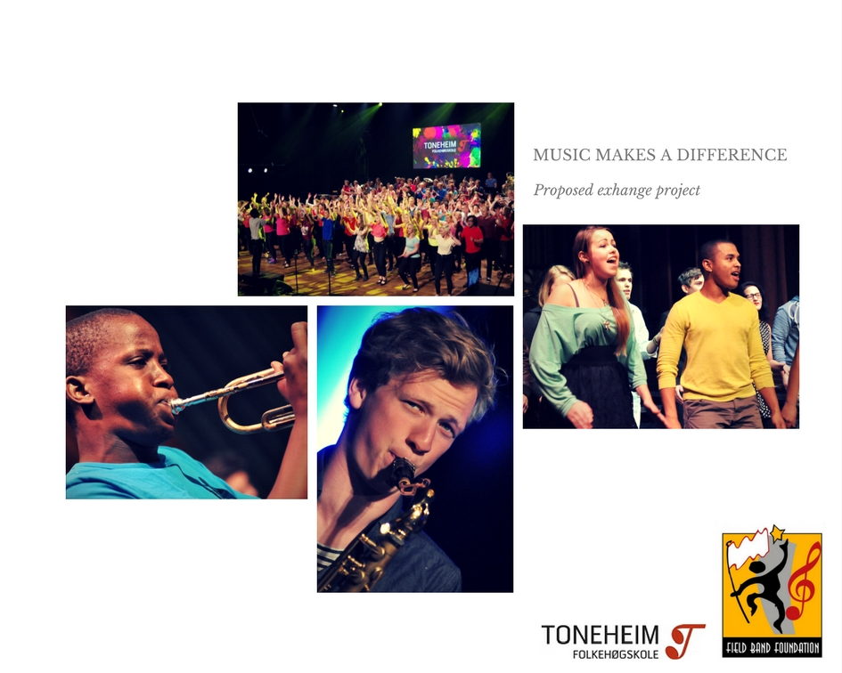
Table of contents
1. Fact Section 3
1.1. Partners 3
1.2. Project name and content: 3
1.3. Project round: 3
1.4. Project duration and standard exchange period 3
2. Purpose of Project 3
2.1. Background 3
2.2. Project results 4
3. Participant administration 6
3.1 Recruitment Procedures for Participants: 6
3.2. Managing the Technical Aspects of the Exchange Programs 7
4. Project administration 7
5. Main Activities to be performed 7
5.1 Main activities to be performed or completed by the partners before the exchange 7
5.2 Main activities to be performed or completed by the partners during the exchange 7
5.3 Main activities to be performed or completed by the Participants after return 9
5.4 participant contract and travel dates planned 9
6. Participants and intended budget 10
7. Sustainability and exit strategy 10

Fact Section

Partners
Toneheim Folkehøgskole, Hamar, Norway, organisational ID: 970899987
Contact person: Jon Krognes, jon@toneheim.no , +47 920 82 450

The Field Band Foundation, South Africa, organisational ID: 1997/002009/08
Contact person: Nicolette du Plessis, nickydup@fieldband.org.za, +27 60 569 3706

Project name and content:
Music Makes a Difference (MMD)

Project round:
1

Project duration and standard exchange period
- Exchange project round of exchange: 1
- Exchange project period: From August 2018 to May 2019
- Standard exchange period for the participants:
  - 10 months + one week of start-up before the exchange and one week of follow-up work and after coming home.

Purpose of Project
Music Makes a Difference is a proposed exchange project between Toneheim Folk High School and the Field Band Foundation, using music as the primary vehicle to create opportunities for reflection and personal development for the participants around identity, global citizenship and diversity.

Background
The Field Band Foundation (FBF) in South Africa and the Norwegian Band Federation (NMF) have collaborated within two main projects for many years. The first project, Band Crossing Borders (BCB), was initiated in 1999 and funded by Fredskorpset. In Norway, the aim of the project was to introduce the South African perspective of using of music in life skills and social development, and to help create an awareness of North-South issues amongst band members and Norwegians in general. In South Africa, the project was seeking to build musical pedagogical capacity in the trainers of the bands and to develop a consolidated learning facility. Consequently, the Field Band Academy (FBA) was established in 2009 and in six years was staffed largely by Norwegian music educators from the BCB project. BCB closed in 2012.
In 2013, the project PULSE was designed and successfully completed the first three years with funding from Fredskorpset, and another three-year cycle was awarded funding in 2016. With the same “exchange-of-professionals” methodology between NMF and FBF, PULSE’s main goal is to increase and share practical knowledge about the correlation between music, health and social inclusion in the two organizations.
From 2003 - 2016 Toneheim Folk High School in Norway has been a co-partner of these two projects, by hosting the participants from South Africa as students in the school. The folk high school movement has a tradition of lifelong learning, endorsing equality and democracy as core values and the partnership between NMF and FBF was viewed as a practical manifestation of these important principles.
Toneheim Folk High School offers a variety of music subjects, but the core approach is the belief that learning only becomes a significant part of people’s lives if they are actively involved and share responsibility for it. There is an emphasis on self-development through peer interaction, open discussion, dialogue and hands-on experience.
From 2016 the South African PULSE participants were no longer placed at Toneheim as the demands of the next phase of this project required that they be in Oslo and Bergen.
Toneheim feels that without these South African exchange students participating in life at the school, the experience of the students in general will be diminished. The presence of these exchange students was positive for all in a variety of ways – it helped further the social and musical development of both the Norwegians and the South Africans, and provided opportunities to explore notions of identity, social diversity and global citizenship. Toneheim would therefore like to propose a new partnership exchange between FBF and themselves, to sustain this relationship.

Project results
Thematic area of project: Identity, global citizenship and diversity.
Aims
1 | To establish a new exchange project where Toneheim receives and hosts two senior Field Band members for one year as students
2 | To create opportunities where the personal development of all Toneheim students happens in a social setting. This is where ideas meet and mix; students are engaged in discussion and new ideas emerge as a result of these social and musical interactions.
3 | To provide an appropriate educational framework to support these interactions, that entails both speaking and listening, articulating one's views and considering the views of others.
4 | To establish a balanced atmosphere where the rights of all participants to think and speak freely are protected, and to foster the conditions for real and sensitive dialogue which is a pre-requisite for personal development.

Objectives
1 | Students will experience enhanced personal maturity and self-respect, while also increasing the social life skills necessary to engage respectfully and meaningfully within cultural diversity.
2 | The cornerstone of the work will always be the joy of playing music together, which will also lead to increased sense of social cohesion.
3 | Students will better understand their roles and responsibilities as global citizens.
4 | The managements of Toneheim and FBF will benefit from students and members with improved musical and leadership capacities.

  - Activities
The Students will enroll in a one-year course at Toneheim Folk High School, starting in August and ending in the middle of May. Toneheim has dormitory facilities with double rooms, and all students will be living in the dormitory. All the students are enrolled based on their main instrument. Toneheim offers individual lessons on all orchestral and jazz instruments, singing, piano, organ, accordion, guitar, and percussion.
Toneheim offers a variety of exciting musical subjects from high school to university level. At the same time, Toneheim offers serval non-academic subjects and subjects for personal development. The central idea of Toneheim is learning for life; an opportunity to grow both individually, socially, and academically in small learning communities where all students live on campus in close contact with staff and their fellow students. Toneheim does not grant degrees or conduct exams. Norwegian folk high schools are an enrichment of the regular education system, with the aim of nurturing “the whole person”. Students develop knowledge in different music subjects and develop that which they will use every day for the rest of their life: themselves.
Most subjects at Toneheim are about music, including:
- Music theory
- Harmony
- Composing
- Aural training
- Music history
- Interpretation
- Music therapy
- Jazz improvisation
- Conducting

There is a strong emphasis on active musicianship and all students participate in ensembles such as:
- Choir
- Chamber choir
- Wind band
- Brass band
- Big band
- Orchestra
- Chamber music groups
- Jazz bands
Throughout the year there are different projects, individual conversations, electives and seminars that focus on different life skills and personal development such as:
- Global Citizenship
- Teamwork and cooperation
- Management
- Relationships
- Conflict Resolution
- Coaching on self-development, self-esteem and willpower
- Individual and group reflection and dialogue on the students’ backgrounds, their current situation and the various development opportunities they have
The students will have tasks to solve together, but also share happy moments with their peers. One important arena for learning is the school’s social life, including life in the dormitory. Here the students get to form a community that is the common bond within the student body. Working and living with other people provides opportunities for training in cooperation and communication. Creating a well-functioning community requires the ability to solve problems, and so many of the activities will focus on life at the school. The point of this training is to develop democratic attitudes and skills in active citizenship. Through a democratic perspective students learn how to participate in society, government and globally. All students are encouraged to share their own values, experiences, and culture with the rest of the school community. By creating democratic meeting points stereotypes are challenged and empathy is learned. The social life incorporates teachers as well as students. Indeed, everyone at the school is part of the community, and since the school is small, everyone makes a difference.

Participant administration

3.1 Recruitment Procedures for Participants:
A call with the criteria for selection will go out through the internal Field Band Foundation communication systems, including Facebook, Twitter and internal memos to all management staff. Applicants will need to be Project Officers, tutors or Band Coordinators and should have a minimum of 3 years’ experience in the FBF. Graduates of the Field Band Academy will have preference as they will have had the experience that the Academy training provides, both in terms of managing their own learning, teaching development and having to work in a group under pressure. They must have an interest in working with music as a tool for personal development and diversity. The participants must have good presentation skills and be able to handle the responsibilities of being seen as representative of an important youth leadership development initiative.

3.2. Managing the Technical Aspects of the Exchange Programs
The exchange project is organised by Field Band Foundation and Toneheim Folk High School. Field Band Foundation has the main responsibility for what will be needed to be done in South Africa, such as selection of candidates, necessary preparations in South Africa, managing candidate commitments in South Africa, and other tasks that must be solved from South Africa. Toneheim is responsible for everything that will be needed to be taken care of from Norway. Visa application, travel in Norway, all that is needed for your stay in Norway as well as applying for funding and sponsorship.

Project administration
The Administration of the exchange project is managed in a collaboration between Field Band Foundaion and Toneheim Folk High School. The project has a rather limited and simple structure, and in the activities most of the factors are known in advance. It is therefore preferred that the time and resources on the actual administration of the project is limited. The Project administration should meet once a year for evaluation and conversation about the project.

Main Activities to be performed

5.1 Main activities to be performed or completed by the partners before the exchange

Description of how Toneheim Folk High School are planning to get the funding for the exchange project

Toneheim Folk high school will apply to different founding’s and grants for the start (round 1) of the exchange project. In the long run we wish this exchange project to be a student driven exchange project. The students' initiative, commitment and proposal to raise money for the exchange project will be handled and supervised by the management staff at Toneheim.

Description of how Field Band Foundation will prepare new exchange participants
Field Band Foundation will arrange a two-day preparatory course for the participants before departing to Norway. Content for this will be divided into three parts;
- Contracts, visa requirements and financial matters
- Work tasks to be completed while on exchange
- Cultural awareness and expectations, basic language and information about Norway.

5.2 Main activities to be performed or completed by the partners during the exchange
33 Preparatory course in South Africa
34 Arrival week.
35 Introduction week – choosing electives, starting up with wind band or brass band
36 Mountain trip
37 – 40 School weeks – Establishing small mixed ensemble
41 Autumn holiday
42 – 44 School weeks – preparing for family day
45 Family day week
46 – 50 School weeks – preparing for Christmas concert
51 Christmas concert – Christmas arrangements.
51 – 52 Christmas holiday - leaving for South Africa
1 Arrival Norway
2 – 7 School weeks – Preparing for spring concerts
8 Winter holiday
9 School week
10 Kindergarten project
11 – 13 Preparing for school trip to Budapest – concert tours In Norway
14 – 15 School trip Budapest
16 Easter holiday
17 – 19 Preparing for ending show – end of Toneheim year.
20 Homecoming course in South Africa

Description of how Toneheim Folk High School will prepare and integrate the exchange participants while staying at Toneheim Folk High School.

- The participants from SA will arrive at Toneheim a few days before the official opening of the school year. This way we can prepare them for the school start and also have the change to get the equipment they need for the school year. The Internatleder at Toneheim Folk high School will help them to organize sleeping bags mountain shoes, thermos, clothing for the outdoors, winter clothing, beddings and other things they might need.
- The participants will be living in dorms with other Norwegians. They will not be given single rooms. For Toneheim it is important that the other students will be speaking Norwegian as much as possible with the participants from SA. A teacher from Toneheim will be coaching them.
- From the very start the participants from SA will be given 2 hours of Norwegian lessons a week.
- Every morning the Inspector at Toneheim will meet the the participants from SA and ensure that they have received all the information that they need for the day/week.
- The participants from SA will be given “buddies”, which is a student who will be sitting next to them in the aula and elsewhere where information is given. They will be helping with translation.
- The participants from SA will participate in the Corps, brass band and if possible in the orchestra, as well as in all other subjects and the electives that they want to and have the time for.

- The participants from SA are taken out of regular student-interviews but have a resource of 25 teaching hours each. This will be used for coaching in relation to their own development and leadership training in the projects they will participate in during the school year.

- The participants from SA will be given the task of establishing a free ensemble with other Norwegian participants.

- The participants from SA will be given the task of establishing and training a “Toneheim Field Band” consisting of all students so that they can perform in Budapest and at the end of the year concert.

- The participants from SA will get leadership tasks (compared to the other students where this is natural) that will challenge them both in leadership and in terms of personal development.

Description of what kind of activities that are expected of the exchange participants while staying in Norway
The participant is expected to follow and take part in all activities provided through and by Toneheim Folk High School during the school year.

In addition, the participants will be given a set task that they will work with throughout the year. The main goal for this task is to assist the participants to set personal goals that are written up, monitored, coached and self-assessed at the end of their exchange. Formal panel assessments will be held at the end of the exchange period, one at Toneheim and one in South Africa, where the participants will present their achievements during the exchange.
The assessment tasks will consist of three main areas:
- Personal development
- Leadership and positive role modelling
- Musical development, which also includes preparation for the Associated Board of Royal Schools of Music (ABRSM) exam.
This assessment will be formalised in a personal project description for each participant at the prep course in South Africa. Facilitators at Toneheim will provide coaching and assistance in Norway.

5.3 Main activities to be performed or completed by the Participants after return

Description of how Field Band Foundation wants to do the follow up work after the return home.
The participants will be part of a two-day homecoming course arranged by FBF when they return to South Africa. Content for this course will include:
- How and what the participants can contribute with back to FBF in their set follow-up period after return.
- A panel assessment/presentation for FBF staff
- A mock exam to prepare the participants for their ABRSM exams, both practical and theory.

The participants are also expected to complete a two-month follow-up period that could include information work, ABRSM preparations with other FBF staff and assistance on educational band visits and workshops. The actual tasks will be decided together with the participant and FBF staff on their return to South Africa.

The participants are expected to complete two ABRSM exams, both practical and theory, within the first three months of returning to South Africa. Staff at Toneheim will provide guidance on what grades the participants are ready for. Staff in FBF will make sure the participants are registered with ABRSM in time.

5.4 participant contract and travel dates planned

- Intended contract start (date): 16 August 2018
- Intended contract end (date): 25 May 2019
- Home country and partner: South Africa, Field Band Foundation
- Host country and partner: Norway, Toneheim Folkehøgskole
- Intended date of outward travel: 23 August 2018
- Intended date of return: 12 May 2019
- Holidays Leave and expenses to return to South Africa for Christmas and work with NMF and PULSE in the winter holiday are to be planned, along with provision made for the fall and Easter holiday.

Participants and intended budget

Expenses | Per person | Two exchange students
South Africa expenses (Prep course, homecoming course, visa interviews, ABRSM exam fees and internal travel costs) | 7000,- NOK | 14.000,- NOK
School fees and expenses (Diet, lodging, school trip and pocket money) | 145.000, - NOK | 290.000, - NOK
Visa | 4500, - NOK | 9000, - NOK
Travel to and from South Africa 2x2 | 20.000, - NOK | 40.000, - NOK
Rental of instruments | 15.000, - NOK | 30.000, - NOK
Halth, insurance | 10.000, - NOK | 20.000, - NOK
Clothing, textiles and school supplies | 8.000, - NOK | 16.000, - NOK
Management meeting | 12.500, - NOK | 25.000, - NOK
 | 215.000, - NOK | 430.000,- NOK
TOTAL for round 1: |  | 430.000,- NOK

Sustainability and exit strategy
We aim to run the exchange project for a three-year period, which can be continued for another three years if both of the organizations wants to continue.
Any closure of the project will be due to either organization or both withdrawing from the cooperation. There are no economic factors that may be shared by a possible closure. The completion of the project will be after the existing exchange round has ended after the end of the school year at Toneheim Folk High School.

